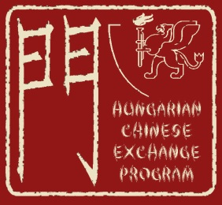 | 
Information for Applicants
Gateway Hungarian-Chinese Exchange Program – Student Mobility – University of Szeged
For the Summer Semester Programme Starting by 10th July, 2017
Please read this notice before filling in the form.
The deadline for the submission of this application form is 31st March 2017. Please attach a recent photo ID to your application. Applications should be sent to: gulyas.laszlo@juris.u-szeged.hu. All received applications will be acknowledged.
Your application will be processed within 2 weeks after reception. Additional information or clarification might be requested from the applicants. If accepted, you will receive an admission notice by e-mail. The tuition fee must be paid in full by wire transfer upon admission and no later than 15th April 2017. Please note that the admission notice in itself is insufficient to start visa procedures.
If you enroll to the three-week long programme (courses and two cultural programmes included) the tuition fee amounts to USD 700/week/person. The tuition fee covers all study materials, some extracurricular activities and accommodation. Please note that the tuition fee does not cover travel expenses and insurance. Any health insurance shall be taken out by you. According to the Hungarian regulations, you will not be eligible for student discount when purchasing transportation or entry tickets. Upon receipt of the payment in full, an invitation letter with detailed information will be sent to the postal address indicated below. You are responsible for obtaining a valid entry visa (“D” category) to Hungary.
Your recommended arrival time to Hungary will be on 10th July 2017. Please note that we can arrange transfer from Budapest airport to Szeged, so please try to book your ticket for the same flights.
The training term ends on 31st July 2017.
All classroom absence must be notified and authorized in advance. Failing to do so might result in denial of certificate.
For further information regarding the Gateway Programme, please visit:
http://www.juris.u-szeged.hu/english/education-141120/kapu-program

