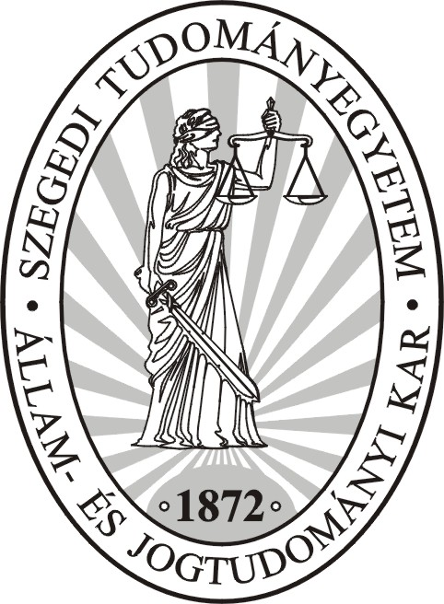 | UNIVERSITY OF SZEGED  Faculty of Law  THE DEAN’S OFFICE  GATEWAY EXCHANGE PROGRAM  6720 Szeged, Tisza Lajos krt. 54. H-6701 Postbox 454  Tel.: (36)-62/544-196, 544-197 Fax: (36)-62/544-204  homepage: http://www.juris.u-szeged.hu e-mail: gateway@juris.u-szeged.hu

GATEWAY EXCHANGE PROGRAM
SUMMER SEMESTER
10 July – 1 August 2017
Draft Program

10 July (Monday)
Arrival at Budapest Airport
Arrival in Szeged

11 July (Tuesday)
Registration (Faculty of Law building)
Dinner

12 July (Wednesday)
Opening ceremony, at Faculty
Lunch break
Dinner

13 July (Thursday)
Free time
Lunch break
Sigthseeing in Szeged
Dinner

14 July (Friday)
Budapest trip

15-16 July (Saturday-Sunday)
Free time

17 July (Monday)
Expert in forensic medicine day: Autopsy, Toxic lab, DNA lab
Lunch break
Expert in forensic medicine day: Introduction to the forensic system of Hungary,
Consultation
Dinner

18 July (Tuesday)
Dr. Péter Durst: Introduction to the Hungarian Culture Lectures (4x45 min)
Lunch break
Prof. Dr. József Hajdú: Introduction to the International, EU and Social Security Law Lectures (4x45 min)
Dinner

19 July (Wednesday)
Prof. Dr. KARSAI, Krisztina: Introduction to the Criminal Justice & Legal terminology
Lunch brea
Dr. habil. SZOMORA, Zsolt: Principles of Criminal
Folklore night

20 July (Thursday)
Dr. habil. FANTOLY, Zsanett : Criminal Justice System in Hungary
Lunch break
Dr. GÁCSI, Anett Erzsébet: Evidence Law
Dr. habil. FANTOLY, Zsanett : Preparation to court
Dinner

21 July (Friday)
Trip to Ópusztaszer National Memorial Park

22-23 July (Saturday-Sunday)
Free time

24 July (Monday)
Dr. habil. JUHÁSZ, Zsuzsanna: Prison system in Hungary and in Europe
Lunch break
Dr. habil. FANTOLY, Zsanett : Visit at the court (Moot Court)
After the Visit
Evaluation seminar (court visit)
Dinner

25 July (Tuesday)
Dr. habil. JUHÁSZ, Zsuzsanna: Preparation to prison visit
Prison Visit (Csillag)
Lunch break
Evaluation seminar (prison visit)
Prof. Dr. KARSAI, Krisztina: Human Rights in Criminal Procedure
Dinner

26 July (Wednesday)
Dr. habil. JUHÁSZ, Zsuzsanna: Human Rights in the Prison
Lunch break
Dr. GÁCSI, Anett Erzsébet: Preparation to police visit
Dinner

27 July (Thursday)
Visit at the police
After the Visit
Dr. GÁCSI, Anett Erzsébet: Evaluation seminar (police visit)
Lunch break
Prof. Dr. KARSAI, Krisztina: Europeanisation of Criminal Law
Dinner

28-29-30 July (Friday-Saturday-Sunday)
Free weekend

31 July (Monday)
Closing ceremony at Faculty of Law
Lunch break
Dinner

1 August (Tuesday)
Transit to Airport

Important venues of the Summer Semester

Faculty of Law, 6720 Szeged, Tisza Lajos körút 54.

Confucius Institute of University of Szeged, 6720 Szeged, Dugonics tér 13.

Szeged City Center Map
